PARKING PERMIT |  |  | DIRECTIONS:  From highway: Take Exit 14W off I-89 on US Rte 2W/Roosevelt Highway/Main Street/Williston Road. Go past Davis Center (large brick building) and University Green, both on right. At traffic light immediately after Green, turn right onto South Prospect St. Turn left at next light onto College St. Take first right into Waterman Parking Lot.  From downtown Burlington: Travel up hill on US Rte 2E/Main Street, turn left onto South Williams St. At next intersection turn right onto College St. Turn left into Waterman Parking Lot.
Event Name: | Vermont Economic Conference
[40 car(s) maximum allotted to permit]
Parking Location: |  | Waterman Lot
Good from start of day on: |  | 1/30/2024 Tue
Until end of day on: |  | 1/30/2024 Tue
Please note all campus weekday parking is by permit only. To avoid warnings and/or citations, you must park in the authorized area indicated on the permit and display the permit face up on the driver's side dash. Thank you for cooperation.
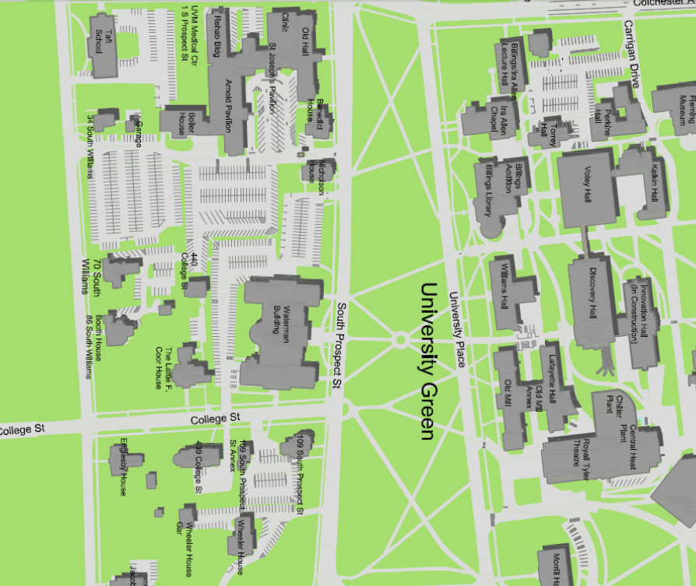
302915
Waterman Lot

