PARKING PERMIT |  |  | DIRECTIONS:  From highway: Take Exit 14W onto Williston Rd./Main St./US Rte. 2 W. Once past DoubleTree Hotel (right side of road) go through two traffic lights (second traffic light crosses Spear St./East Ave.). After second traffic light, take first right (this is a soft right). Take next left for the Jeffords Lot.  From downtown Burlington: Travel up hill on Main St./US Rte. 2 E. Turn right onto Spear St. Merge left immediately. At traffic light turn left onto Main St. Continue straight through next traffic light then take a right (this is a soft right). Take next left for the Jeffords Lot.  This parking permit may not be used to park in the ‘Pay-by-Space’ parking spaces. These spaces are numbered.
Event Name: | Vermont Economic Conference
100 car(s) maximum allotted to permit]
Parking Location: |  | Jeffords Lot
Good from start of day on: |  | 1/30/2024 Tue
Until end of day on: |  | 1/30/2024 Tue
Please note all campus weekday parking is by permit only. To avoid warnings and/or citations, you must park in the authorized area indicated on the permit and display the permit face up on the driver's side dash. Thank you for cooperation.
302915
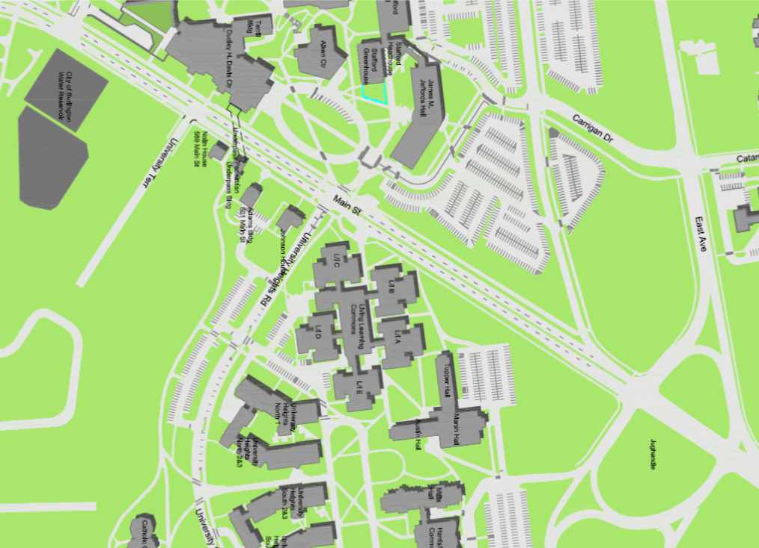
Davis Center
Jeffords Lot

Jughandle
Main St.

