PARKING PERMIT |  | DIRECTIONS:  From highway: Take Exit 14W off I-89 on US Rte. 2W/Main St./Williston Rd., past DoubleTree Hotel and take slight right onto East Ave.. Take immediate left and cross Main St. onto Spear St. Take second right onto PFG Rd. and an immediate left into Gutterson Garage. You must park inside the garage or on the top level.  From downtown Burlington: Travel up hill on US Rte 2E/Main St., turn right onto Spear St. Take second right onto PFG Rd. and an immediate left into Gutterson Garage. You must park inside the garage or on the top level.  Note: You must park INSIDE the garage, as this permit is not valid in: the hourly paid numbered spaces (depicted by white lines on the pavement) along the east wall of the upper deck of the Gutterson Garage.
Event Name: | Vermont Economic Conference
60 car(s) maximum allotted to permit]
Parking Location: | Gutterson Garage
Good from start of day on: | 1/30/2024 Tue
Until end of day on: | 1/30/2024 Tue
Please note all campus weekday parking is by permit only. To avoid warnings and/or citations, you must park in the authorized area indicated on the permit and display the permit face up on the driver's side dash. Thank you for cooperation.
302915
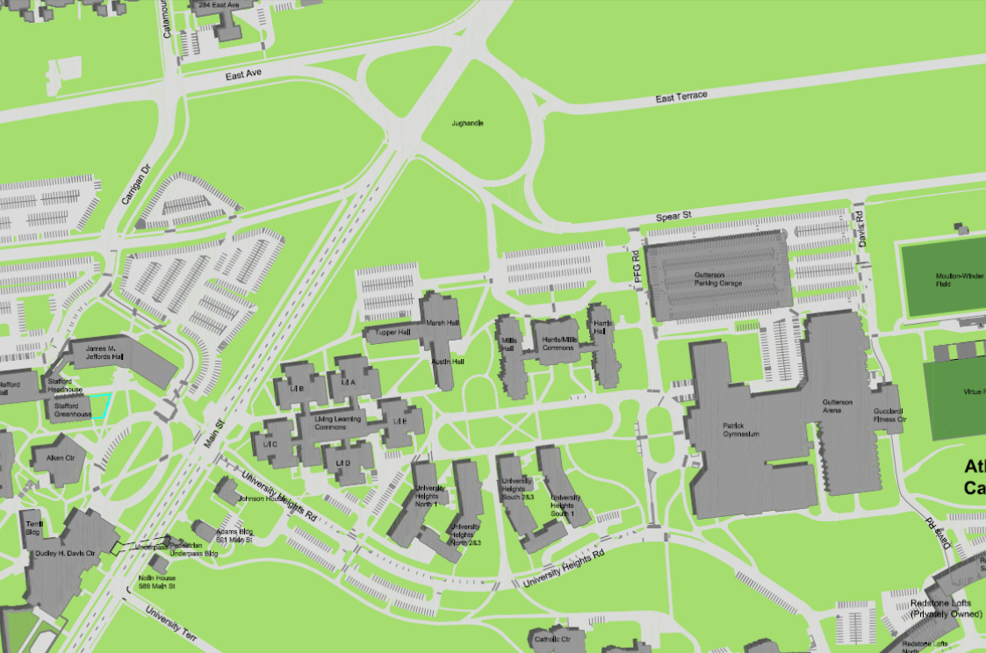

Davis Center
Gutterson Garage

P

