PARKING PERMIT |  |  | DIRECTIONS:  From highway: Take Exit 14W off I-89 on US Rte. 2W/Main St./Williston Rd. Travel approximately 0.8 miles and take left onto South Prospect St. and then an immediate left into the Allen House Lot (behind the Allen House, 461 Main St., Burlington, VT).  From downtown Burlington: Travel uphill on US Rte. 2E/Main St.; at South Prospect St. turn right. Take an immediate left into the Allen House Lot (behind the Allen House, 461 Main St., Burlington, VT).
Event Name: | Vermont Economic Conference
40 car(s) maximum allotted to permit
Parking Location: |  | Allen House Lot
Good from start of day on: |  | 1/30/2024 Tue
Until end of day on: |  | 1/30/2024 Tue
Please note all campus weekday parking is by permit only. To avoid warnings and/or citations, you must park in the authorized area indicated on the permit and display the permit face up on the driver's side dash. Thank you for cooperation.
302915
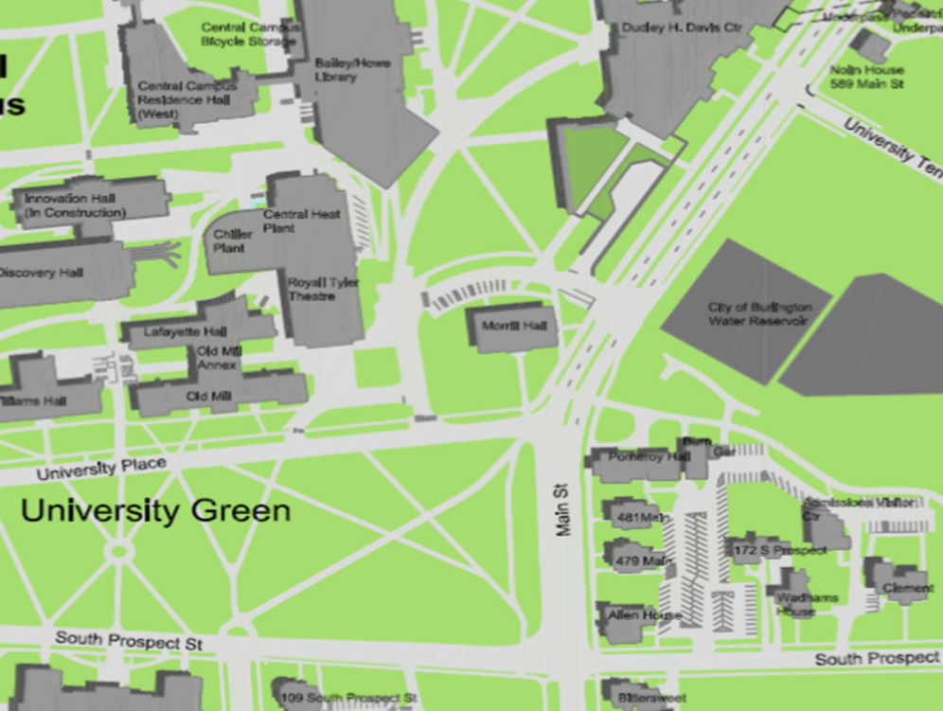
Allen House Lot

